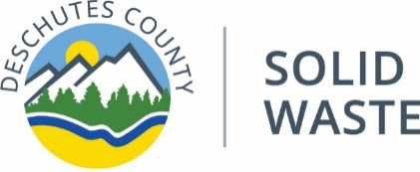
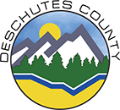

PLANNING FOR THE FUTURE
June 25, 2018—Open House Meeting Notes
Deschutes County Fact Sheet
Deschutes County is preparing a Solid Waste Management Plan (SWMP)

Questions
- Are you currently hauling anything to Boardman? (All the waste generated in Deschutes County stays in Deschutes County.)
- What agencies require people with homes to sign up for service? (Not Deschutes County or the City of Bend)
- How do you decide what to charge for and what is free? (For items on the state list, we can’t charge. But things that are banned we can charge for.)
- I want to support the idea that if you use more, you pay more.
- Is there a place here that we can deposit our food waste? We are interested in that. (Not yet, but we will add this to the list of things to look at.)
- Have you looked at increasing recycling from multifamily? (We are working on providing adequate space for curbside and getting more people to use it through education.)
- Does Knott Landfill take clean lumber cut-off pieces? That should not go to the landfill. You should put it out there so people can pick it up for free.
- What is the benefit of having public meetings—it seems to tangle up the process. (We want to hear from the people who are paying for the service they receive.)

