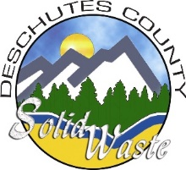
Deschutes County Department of Solid Waste
Solid Waste Advisory Committee (SWAC)
January 23, 2018
11:00 a.m. – 3:00 p.m.

 | Committee Members:
 | Jerry Andres  Citizen at Large |  | Brant Kucera  City of Sisters |  | Smith Reese  Citizen at Large
 | Brad Bailey  Bend Garbage and Recycling |  | Catherine Morrow  Citizen at Large |  | Mike Riley  The Environmental Center
 | Jared Black  Citizen at Large |  | Jake Obrist  City of La Pine |  | Erwin Swetnam  Cascade Disposal
 | Bill Duerden  City of Redmond |  | Gillian Ockner  City of Bend |  | Rick Williams  Citizen at Large
 | Consultant(s):
C | Doug Drennen  JRMA | C | Libby Barg  Barney & Worth
 | Dept. of Solid Waste Staff:
S | Chad Centola  Operations Manager | S | Debbie Parret  Administrative Analyst | S | Todd Sween  Operations Manager
S | Sue Monette  Management Analyst | S | Timm Schimke  Director
 | Guest(s):
G | Denise Rowcroft  The Environmental Center | G | Randy Stutzman  Bend Garbage and Recycling
 | Present at meeting | * | Teleconference
C | Consultant | G | Guest | S | Staff

Decisions/Actions Taken by the Committee in Blue
Items Requiring Follow-up in Red

Call to Order: The meeting was called to order by Timm Schimke, Deschutes County Department of Solid Waste Director, at 11:00 a.m.

- Welcome & Introductions: Timm Schimke introduced Doug Drennen, JRMA consultant and the Solid Waste Management Plan (SWMP) Project Manager, and the other Department of Solid Waste Staff in attendance. Committee members and attendees gave brief introductions such as name, company, and background.

Doug Drennen provided a short background on JRMA and his team, including Libby Barg from Barney & Worth who handles the project Public Relations. The primary purpose of the initial SWAC meeting was to complete an orientation of the purpose and process to be used to prepare a comprehensive Solid Waste Management Plan.
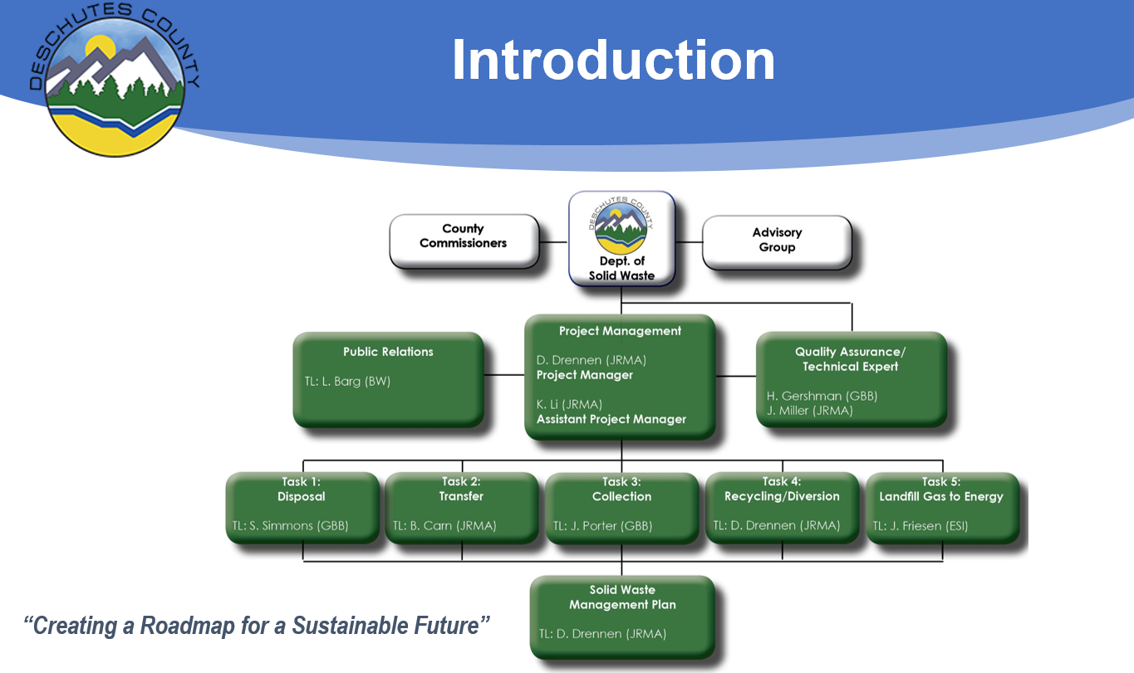

- Overview of Deschutes County Solid Waste Department and Knott Site Plan: Timm Schimke presented an overview of the current solid waste system. Integrated solid waste management includes the collection, recycling, transfer system, and disposal components along with system financing.

  - Collection Component:
    - City / County Franchises
    - Minimum Service Level
    - Maximum Fee
    - Financial Monitoring and Franchise Fees

  - Recycling Component:
    - City / County Franchises
    - Minimum Service Level
    - Maximum Fee
    - Financial Monitoring and Franchise Fees

  - Transfer System Component:
    - City / County Franchises
    - Minimum Service Level
    - Maximum Fee
    - Financial Monitoring and Franchise Fees

  - Disposal Component:
    - Environmental Regulation/Protection
    - Knott Landfill
      - Capacity
      - Gas/Leachate Systems Management
      - Environmental Monitoring
      - Landfill Gas to Energy
      - Closure/Post Closure
    - Future Disposal

The SCADA system is an electronic tool providing pump monitoring and reporting functionality while controlling leachate recirculation.

  - System Financing:
    - Tip Fee Revenue
    - Sale of Recyclables
    - Revenue from Energy Recovery
    - No tax based support at this time

The Solid Waste Department is funded entirely from revenues generated primarily at disposal facilities. A small amount of revenue comes from sales of recyclables. No tax based financial support is received.

- SWAC Participation: Doug Drennen & Libby Barg

  - Assignment: SWAC members are tasked with providing input on how Deschutes County processes solid waste after the Knott Landfill reaches capacity by evaluating disposal options and examining other aspects of the solid waste system: collection, recycling and transfer.

  - Expectations:
    - Attend regular monthly meetings (Jan. – Fall 2018).
    - Read information provided and ask questions when clarification is needed.
    - Offer views and recommendations based on understanding of the information presented.
    - Work toward a consensus with dissenting opinions documented.
    - If contacted by the media, please speak as an individual and not for the SWAC.
    - All discussions regarding recommendations will be conducted at publicly noticed meetings.
    - Beware – avoid – declare – conflicts of interest.

  - Public Process: SWAC meetings are open to the public with announcements and updates published on the County website. Timely mailings to interested parties will occur. The proposal is to have two public workshops/meetings, one following completion of the draft for chapters 1 – 4, the next as chapter 6 is being developed.

Action: The County will create a web page for the public to view information on the plan. Minutes from the meeting will be posted on the webpage and sent to the SWAC.

Action: The Consultant team will send information to the SWAC at least 10 days prior to the next scheduled meeting. SWAC meetings will include a presentation by the consultant team of new information and then a discussion by the SWAC. Public comments will be heard at each meeting.

- Site Tour of Deschutes County Transfer and Recycling Facility: Timm Schimke provided a tour of the Deschutes County Knott Landfill Recycling and Transfer Facility, including the compost facility operated by Deschutes Recycling.

  - Chapter 1 – Introduction to SWMP: Doug Drennen

  - Primary Goal of SWMP: “To work cooperatively with Cities and service providers to offer citizens and businesses an integrated solid waste management system that delivers quality and cost-effective services while achieving the best use of our resources and reducing waste disposed in landfills.”

  - Key Objectives & Evaluating Factors:
- To provide an integrated solid waste management system that addresses an effective combination of strategies and programs guided by the hierarchy adopted by the state.
- To continue educating consumers in order to promote practices and methods to reduce the long-term per capita waste generation rate.
- To develop programs and support implementation of system improvements that seek to ensure materials recovered from the waste stream attain the highest and best use and are recycled.
- To develop a solid waste system that is based on sound financial principles, provides cost effective services and maintains rate stability over a long term, while allocating costs equitably to all users.
- To maintain system flexibility to respond to changes in waste stream composition, waste management technologies, public preferences, new laws and changing circumstances.

  - Key Issues:
- Current recovery rate is 33%. New goal is 45% by 2025.
- Address impacts based off the current collection services, considering the growth in population.
- Consider strategies to extend the site life of Knott Landfill?
- Are there proven and reliable technologies that would reduce the County’s dependency on landfill disposal?
- What is the best approach for providing for reliable and cost effective long-term disposal capacity?
- What investments/improvements are needed at the County’s transfer station to address the long-term system needs and to provide convenient cost-effective services?
- What is the best approach to optimize the extraction and utilization of landfill gas generated at the Knott Landfill?
- What is the best approach for funding the capital improvements required to meet the future solid waste system needs?
- Consider regional approaches to provide cost effective services that benefit the greater central Oregon region.
- What is the timeline/schedule when critical investments in the solid waste system are needed?

Action: Section 1.3 Item 4: Mike Riley proposed having the Consultant team expand the issue to include “…and enhance resource recovery.”

Action: Section 1.3: Mike Riley and Gillian Ockner recommended adding a statement to reinforce a goal to reduce impacts on greenhouse gas or related climate change. The factor could compliment the City of Bend’s Climate Action Process soon to be under development by the new Climate Action Process Steering Committee. The Consultant team will research and Mike Riley will assist in preparing a draft statement for consideration.

  - Plan Organization:
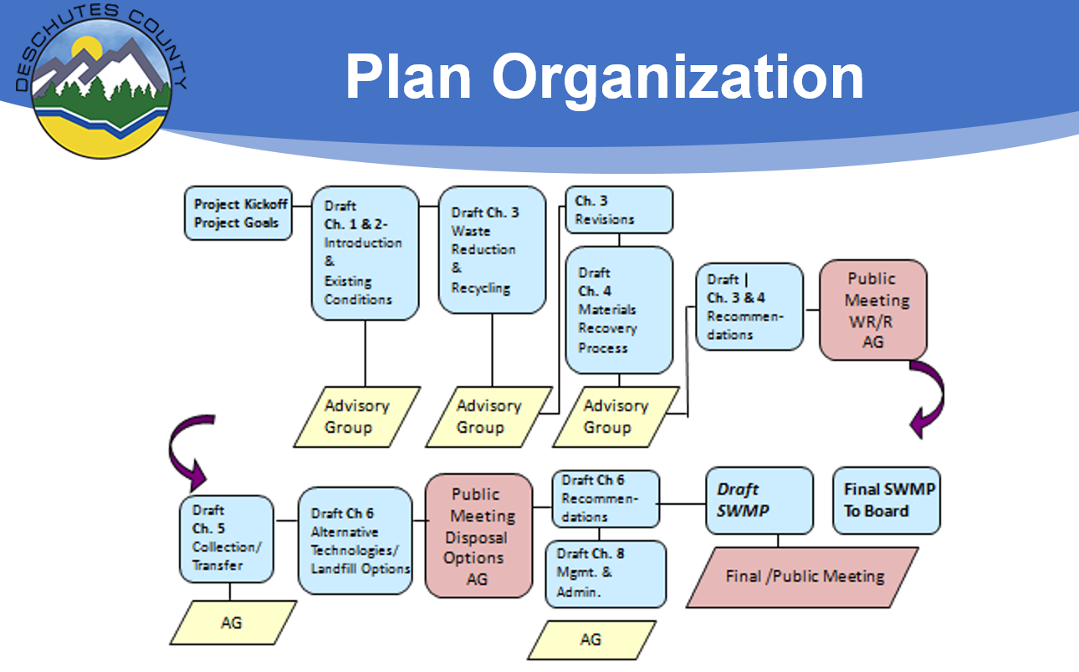

- Chapter 2 – Background and Existing Conditions: Doug Drennen presented the Background and Existing Conditions chapter of the draft SWMP. This information is to be used as reference data as the future components of the SWMP are prepared.

  - Characteristics of the Planning Area:
    - Table 2-2: 2016 Estimated Population of Cities in Deschutes County, OR
    - Table 2-4: Solid Waste Tons Per Year
    - Figure 2-2: Graph of Annual Solid Waste
    - Figure 2-1: Deschutes County Solid Waste System

  - Transfer Stations:
    - Figure 2-3: Transfer Station Locations
    - Table 2-6: Remote Transfer Station Tonnages
    - Figure 2-4: Yearly Transfer Station Tonnages
    - Table 2-8: Deschutes County Tonnage to Disposal Operations
    - Table 2-9: Annual Recycling Materials Recycled at Transfer Stations in Tons per Year (2016)
    - Figure 2-5: Yearly Recycling Rates Wood/Yard Waste (Tons per Year)
    - Table 2-10: Deschutes County Commingled Recyclables Collected by Haulers Past 3 Years (Tons per Year)

  - Historical Data:
    - Table 2-11: Summary of historic waste stream data for Deschutes County between 2010 and 2016 (in tons)
    - Table 2-12: Per Capita Rates (pounds per capita per year)
    - Table 2-13: Deschutes County Waste Stream for 2016
    - Figure 2-6: Composition of Waste Disposed in the County
    - Table 2-15: Deschutes County Waste Stream Projections
    - Figure 2-7: Waste Generation Per Capita Rates

  - Take Away Chapter 2:
- Knott Landfill expected to close by 2029 (11 years).
- Total waste generated is estimated to increase from 240,000 TPY in 2016 to almost 300,000 TPY in 2030.
- To meet recovery rate goal of 45% would require that 135,000 TPY are diverted from landfill or 55,000 additional tons (~70% increase).
- Waste received at transfer stations has increased from 54,000 TPY in 2012 to almost 100,000 TPY in 2017 (~85% increase).
- With over 100,000 visitors per month, tourism has an impact on waste management system.

Action: Take Away Chapter 2 Item 5: It was mentioned the description of the demographics of the County need to be updated. The draft chapter currently contains information extracted from existing websites. Gillian Ockner recommended contacting the tourism agencies to see what they are estimating for future visitor counts. The Consultant team will research and provide updated information regarding demographics and data on tourism.

- Questions/Comments/Issues

- Next Meeting: SWAC Advisory Group meetings will be held the 4th Tuesday of each month at the Deschutes Services Building (1300 NW Wall St., Bend, OR 97703) from 2:00 p.m. – 3:30 p.m. Public meetings will be held in the evening. The next Solid Waste Advisory Committee meeting is February 27, 2018 2:00 p.m. – 3:30 p.m.

Meeting Adjourned: 3:05 p.m.

